Department of Biochemistry
Royal School of Bioscience (RSBSC)
The Assam Royal Global University, Guwahati

Dr. Babiangshisha Kharbuli, Ph.D.
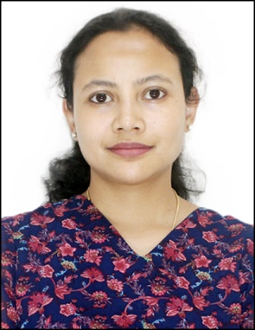
Assistant Professor, Department of Biochemistry
B.Sc. (St. Anthony’s College, Shillong, Meghalaya), M.Sc. and Ph.D. in Biochemistry (North-Eastern Hill University, Shillong, Meghalaya), UGC NET-JRF
Research interest: Nutrient sensing pathways, gerontology and inflammation
Research experience: 5 years (PhD)
Research publications: 1 (International)
Life membership: Association of gerontology, India
Email: bkharbuli@rgu.ac
Google Scholar link:
https://scholar.google.co.in/citations?view_op=list_works&hl=en&user=z31Ge8gAAAAJ

